Data Structure & Algorithm

----------------Main--------------------  
\*Mine class  
+ firstClick(): receive the box with coordinate x and y as parameter  
- first loop for:  
. function will set the box at the coordinate x and y with 8 boxes around it as revealed boxes with no mine  
. then the rest other boxes will be set up randomly  
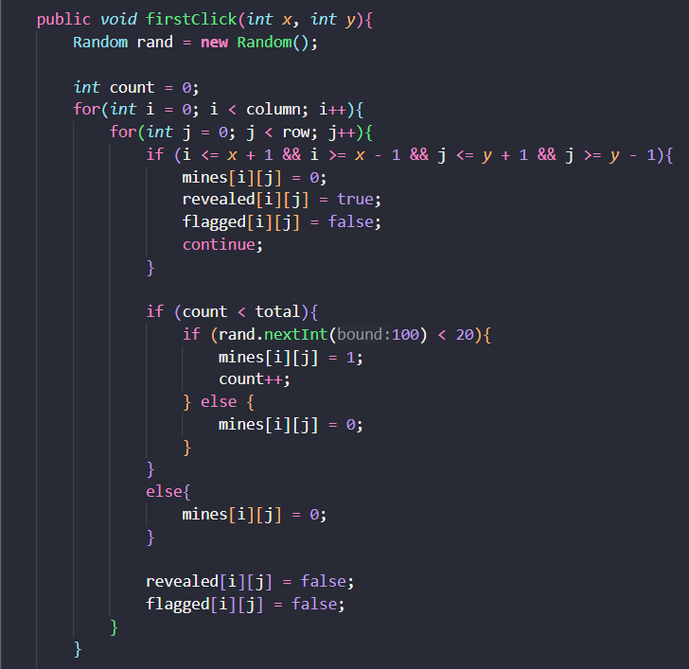  
. Time complexity: O(N^2)  
- second loop while:  
. its loop will handle for the rest mines that have not been set up in the board – since with above function, it will randomly set whether the box has a mine or not, it would leads to some case that there are some remaining mines have not been set up  
. of course, it excepts the nine boxes in the area of the firstClick  
- third loop for:  
. its function will set up for each box how many mines around it

. Time complexity: O(N^4)

+ emptyCell(): receive the box with coordinate i and j as parameter  
- if clicked the box with no mine, then the function will set up 8 boxes around visible  
- then push to stack the specific value of its combined coordinate of the box with type – we know that these boxes must be in the series of revealing boxes  
. Time complexity: O(N^2)

\*Board class  
+ MouseClicked()  
- this if will allow player to put and remove flags on the box  
  
- if do not follow above function, we move this function  
. if the box is flagged, we can not do anything with this box  
. if the box is not flagged, then there 2 function  
-> 1: if click the unrevealed box ,   
=> if the box has mine, you lose,   
=> if the box has no mine, but the box has neighbors, then it opens 1 box only  
=> if the box has no mine, but the box has no neighbors, then it opens 8 boxes around its box also  
-> 2: if click the unrevealed box, it is a new feature function see below with fillCell()  
. all of function will push to stack a specific value of combined coordinate of the box  
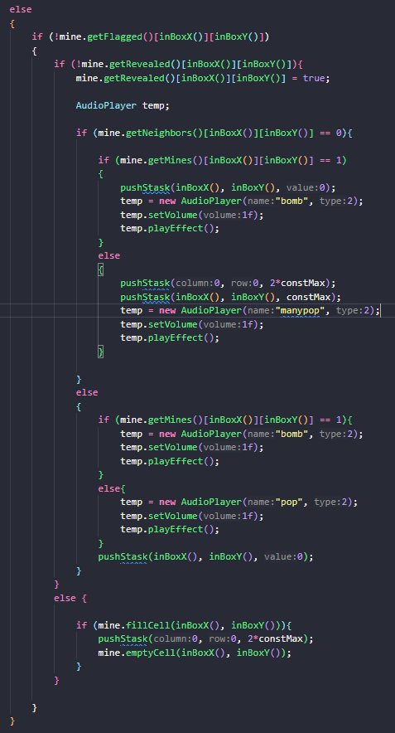

+ pushStack()  
- all pushStack will setup with column, row as coordinate x, y of the box  
. if click to reveal only 1 box or the mined box, the value is set as 0  
. if click to reveal also the 8 boxes around the center box, there are 2 function pushStack:   
-> the first func will set with value (0,0, 2\*constMax) – the mark the beginning of series of revealing box  
-> the second func will set with column, row as coordinate x, y of the box and the value constMax – to distinct this value in series with the value not in series  
- with some variable  


+ undo.inUndo()  
- first, it will check whether the value is in series or not  
. if in series, it will pop value until it reaches value 2\*constMax – the beginning of the series  
. if is not in series, it will check whether the box has mine or not  
=> if the box has mine, it will activate the smileyUndo() – undo for only bomb :v  
=> if the box do not have mine, it pop as normal

+ level.inLevel()

\*Smiley class  
+ resetAll()  
+ resetUndo(): reset for clicking the bomb

\*New Features  
Mine Class  
+ fillCell(): receive the box with coordinate x and y as parameter  
- when player know that all the mine around 1 center box have been flagged, player can click the center box and then the rest of 8 boxes around it having no mine will be revealed

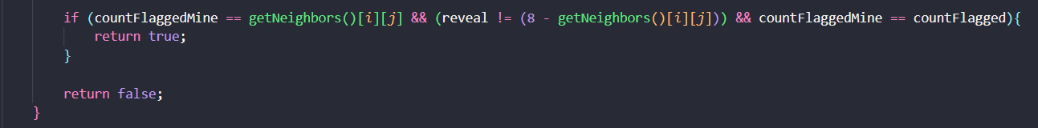  
. Time complexity: O(N^2)

----------------Other class--------------------  
Level class  
Undo class

Flagger class  
GameState class  
Life class

TimeCounter Class

AudioPlayer Class

Menu Class

----------------------Design Pattern---------------  
\*Singleton Patern  
